Fundamentals of Software Development

Assessment Task 1 – Part 1

Cmp1_07
Group 6

Sheyda Niaparast - 26496772
Huilin Zeng - 26310336
Chengfeng Yang - 26642759
Sihan Yin - 26151769

Spring Semester
2026

Table of Contents
1. User-Story Backlog 3
1.1. Narrative user stories 3
1.2. Requirements table (backlog) 4
2. UML Use-Case Diagram 6

- User-Story Backlog
The university requirements were transformed into simple, generic user stories. Each story was first expressed in a narrative form “As a [user], I want to [do something] so that [result happens],” then organized into the required backlog columns: ID, User, Action, Result / Outcome, and Function. Each story captures one main action and its expected result. The stories focus primarily on user goals and meaningful system behavior. Every story has a unique three-digit ID, and stories belonging to the same feature share the same hundreds digit: 1xx Login, 2xx Register, 3xx Enroll, 4xx Drop, 5xx View, 6xx Change Password, 7xx Admin, and 8xx File I/O. “System” appears in the User column where the action is performed automatically by the application.

1.1. Narrative user stories
1xx — Login
• As a student, I want to log in with my email and password so that I can access the student subsystem.
• As the system, I want to validate the login details so that invalid credentials can be rejected.
2xx — Register
• As a student (unregistered), I want to register with my name, email and password so that I become a student who can use the system.
• As the system, I want to validate the registration details and assign a unique student ID so that a valid student record can be created.
3xx — Enroll
• As a student, I want to enroll in a subject so that it is added to my enrolment list.
• As the system, I want to create a subject with a unique ID, random mark and grade so that the enrollment information is complete.
• As the system, I want to check the number of enrolled subjects so that a student can’t enroll in more than four subjects.
4xx — Drop
• As a student, I want to drop a subject so that it is removed from my enrolment list.
5xx — View
• As a student, I want to view my enrolment list so that I can see my subjects, marks and grades.
• As an admin, I want to view all registered students so that I can see every student on file.
6xx — Change Password
• As a student, I want to change my password so that my login credentials stay up to date.
• As the system, I want to validate the new password so that only a password meeting the required pattern is accepted.
7xx — Admin
• As an admin, I want to view, organize and categorize all students so that I can monitor their results.
• As an admin, I want to remove a student or clear all records so that I can organized the student data as I see fit.
8xx — File I/O
• As the system, I want to save and load student data so that information persists between sessions.

1.2. Requirements table (backlog)
ID | User | Action | Result / Outcome | Function
1xx — Login
101 | Student  (R) | log into the application if given valid credentials | student is taken to the student subsystem | login()
102 | System | match the entered email and password with the ones on file | a registered student is authenticated | match_credentials()
103 | System | verify the entered email and password against the required patterns | malformed input is rejected before it is checked against the file | validate_credentials()
104 | System | show an error message when the credentials do not match | the student is told the login failed and can retry | show_login_error()
2xx — Register
201 | Student (U) | register by entering a name, an email and a password | a new student account is created | Register_account()
202 | System | validate the email against pre-defined patterns (e.g. emails should end with the domain @university.com) | only valid university emails are accepted | validate_email()
203 | System | validate the password (upper-case start, at least five letters, followed by three or more digits) | only passwords meeting the criteria are accepted | validate_password()
204 | System | generate and assign a unique six-digit student ID (zero-padded, 1–999,999) | each student is uniquely identified | generate_ID()
205 | System | show an error message when the Register details are invalid | the visitor is prompted to re-enter valid details | show_register_error()
3xx — Enroll
301 | Student (R) | request to enroll in a subject | the enrolment request is submitted | enrol_subject()
302 | System | auto-generate a random mark between 25 and 100 for the enrolled subject | the subject is assigned a mark | generate_mark()
303 | System | calculate the subject grade from its mark (Z / P / C / D / HD on the UTS scale) | the subject is assigned a grade | calculate_grade()
304 | System | reject enrolment when the list already holds four subjects | the student is notified the four-subject limit is reached | check_subject_limit()
305 | System | generate a unique three-digit ID for the subject (001-999) | a subject ID between 001 and 999 is assigned | generate_subject_ID()
306 | System | add the generated subject to the student’s enrolment list | the new subject is included in the student’s enrolments | add_subject()
307 | System | show an enrolment-limit error when the student already has four subjects | the student is notified that no more subjects can be added | show_enrolment_limit_error()
4xx — Drop
401 | Student  (R) | remove (drop) a subject from the enrolment list | the selected subject is removed from the list | remove_subject()
5xx — View
501 | Student  (R) | view the current enrolment list | all enrolled subjects with their marks and grades are displayed | view_enrolment()
502 | Admin | view all registered students | every student on file is displayed | view_all_students()
6xx — Change Password
601 | System | validate the new password against the required pattern | only a valid new password is accepted | validate_password()
602 | Student  (R) | update the student’s password | the valid new password replaces the previous password | update_password()
7xx — Admin
701 | Admin | access the admin subsystem without registering | existing staff can manage students directly | admin_access()
702 | Admin | organize and view students grouped by grade | students are displayed grouped by grade | group_by_grade()
703 | Admin | categorize students into PASS/FAIL by mark (mark < 50 → FAIL; mark ≥ 50 → PASS) | students are classified by outcome | categorise_pass_fail()
704 | Admin | remove an individual student | a single student record is deleted | remove_student()
705 | Admin | clear all student records | the students.data file is emptied | clear_all_students()
8xx — File I/O
801 | System | save registered students and their enrolment details to students.data | student data persists between sessions | save_to_file()
802 | System | load student data from students.data on start-up | the data is available to the student and admin subsystems | load_from_file()

- UML Use-Case Diagram
Figure 1 presents the CLIUniApp, a command-line application for student enrolment and administration within one semester. Actors appear outside the system boundary, and solid lines connect them to the use cases they initiate. An <<include>> arrow points to required supporting behavior. An <<extend>> arrow points from additional behavior to its base use case as it represents behaviors that occur under specific conditions. These relationships describe required and conditional behaviors rather than the sequence of user actions.
The CLIUniApp diagram identifies three actors: Unregistered Student, Registered Student, and Admin. The “Unregistered Student” aims to create an account through “Register account”. The student provides a name, email and password. Registration has <<include>> relationships with “Validate email”, “Validate password” and “Generate ID”. The first two check the input against the required patterns. Generate ID assigns a unique six-digit student ID between 000001 and 999999 after validation succeeds. “Show registration error” extends the register function when registration details are invalid. The student must correct the details before an account can be created.
The “Registered Student” aims to access the student subsystem and manage personal enrolments. “Log in” includes two distinct checks: “Validate credentials” checks input formats, while “Match credentials” compares validly formatted input with stored records. The checks correspond to backlog items 103 and 102 respectively. “Show login error” extends the log in function when the credentials do not match. Successful login is a precondition for enrolment, subject removal, viewing the enrolment list and password updates.
“Enrol” in a subject includes “Check subject limit” (304). The separate error message corresponds to backlog item 307. If the student already has four subjects and requests another, “Show enrolment limit error” extends enrolment and no subject is added. A permitted enrolment includes “Generate subject ID”, “Generate mark” and “Add subject”. The system creates a unique three-digit subject ID, assigns a random mark from 25 to 100 and adds the subject to the student’s list. The student does not choose a specific subject. In this diagram, “Generate mark” also includes “Calculate grade”, which assigns Z, P, C, D or HD based on the generated mark.
“Remove a subject” allows the student to drop an existing enrolment. “View current enrollment list” displays subjects, marks and grades. “Update password” replaces the existing password after validating it. Its <<include>> relationship with “Validate password” represents the same password check used during registration.
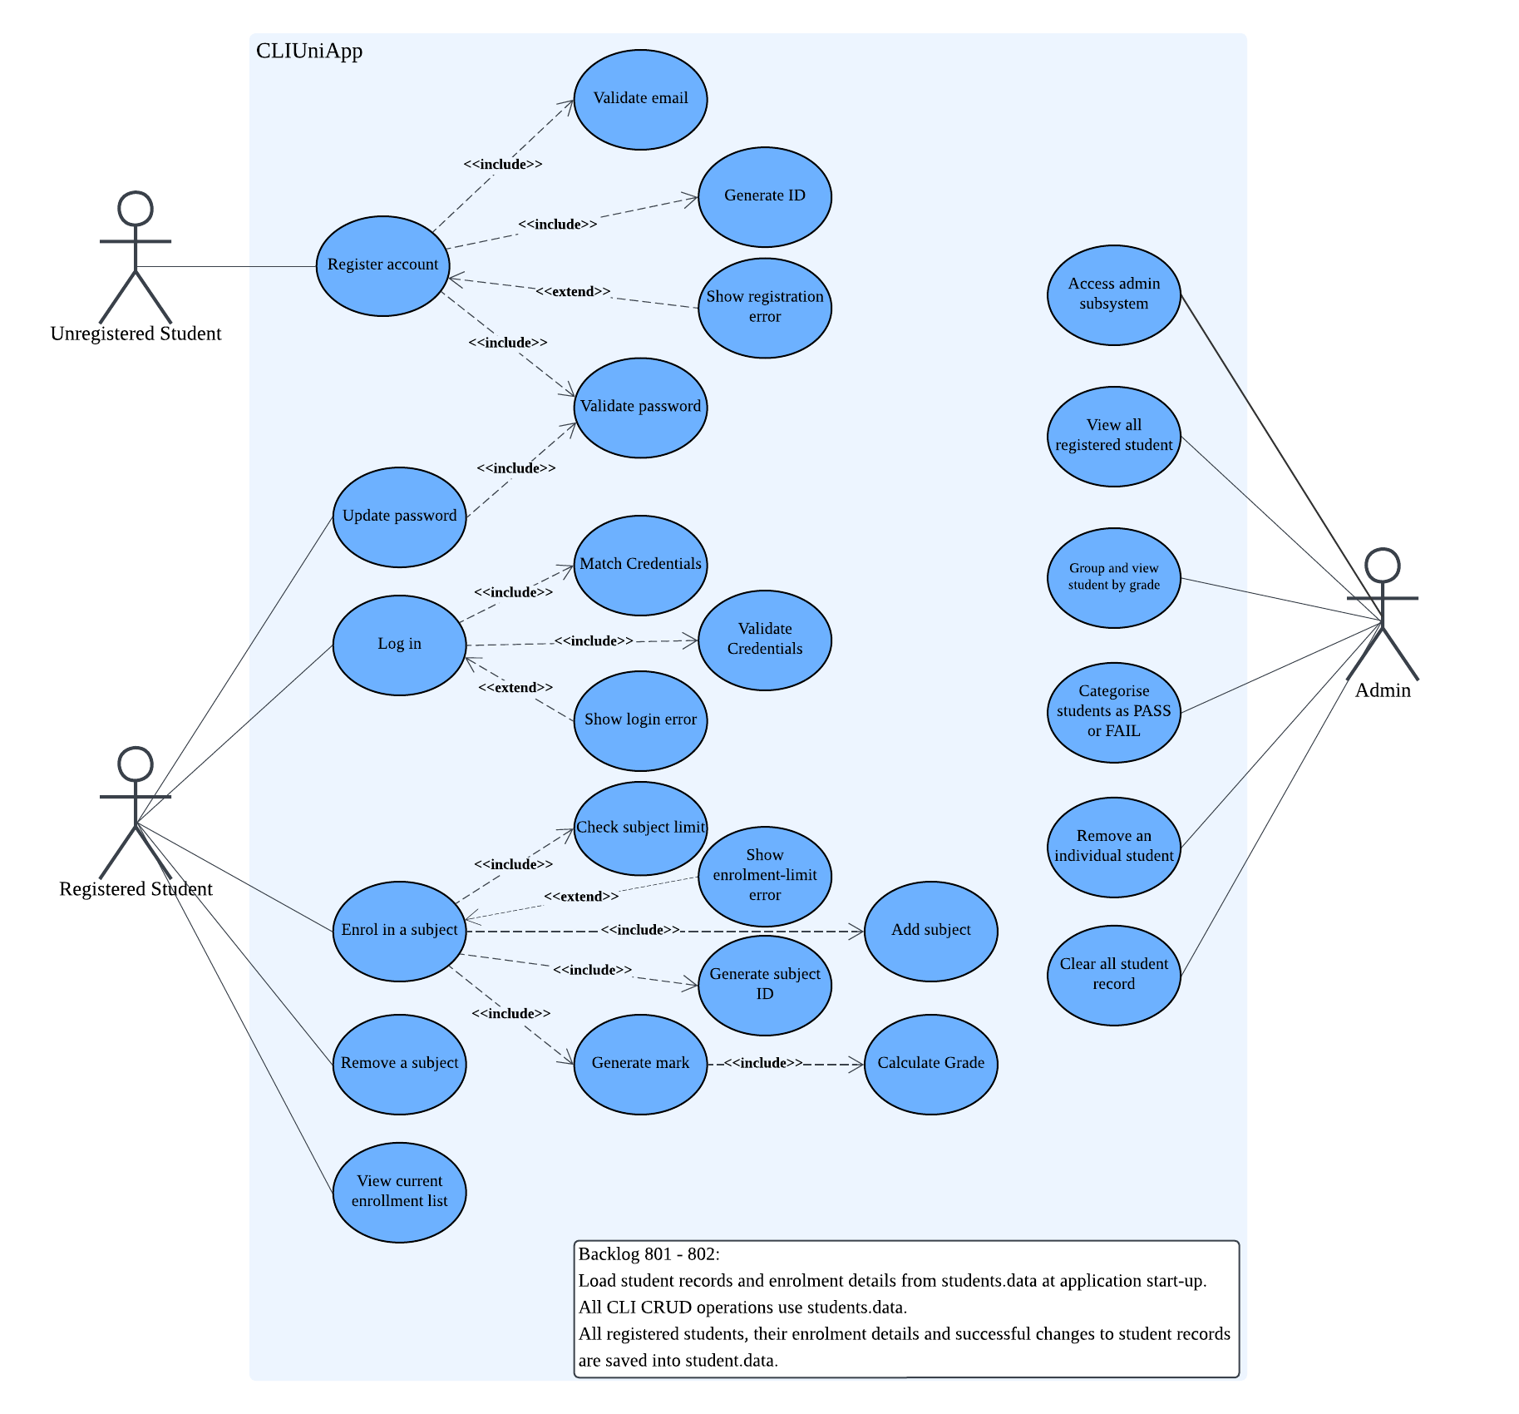
Figure 1. UML Use-Case diagram
The “Admin” represents existing university staff and aims to manage student records through “Access admin subsystem”. “Access admin subsystem” does not require registration. Administrators can view all registered students, group students by grade and categories them as PASS or FAIL. Marks below 50 indicate FAIL and marks of at least 50 indicate PASS. “Remove an individual student” deletes one record, while “Clear all student record” deletes every record. Solid associations connect the admin directly to these management functions.
The diagram’s note covers backlog items 801–802. The application loads student.data at start-up, uses this file for all CLI CRUD operations and saves successful changes. File saving also applies after deletions and password changes. These are shared storage requirements, not separate actors. They support consistent student and administrator access to the same records.

(R) stands for Registered
(U) stands for Unregistered

